1. Name any one type of chicken

………………………………………………………………………………………………

1. Define flowering plant.

……………………………………………………………………………………………..

1. Name the equipment below.
2. Which type of immunity do babies get after being immunized?

………………………………………………………………………………………………..

1. Name the type of worm that enters into our body through bare feet.

……………………………………………………………………………………………….

1. What is NIDs in full?

……………………………………………………………………………………………………………………………………………………………………………………………….

1. What name is given to the master bee in the hive?

……………………………………………………………………………………………….

1. What is floating?

………………………………………………………………………………………………

1. Calculate the density of a stone whose mass is 100gm and volume is 25cm3.
2. Give one importance of transpiration to a farmer.

………………………………………………………………………………………………

1. Name one example of a simple leaf.

………………………………………………………………………………………………

1. How useful is photosynthesis to green plants?

………………………………………………………………………………………………

1. Give one type of germs.

………………………………………………………………………………………………

1. Which part of a cassava plant is affected by cassava mosaic?

………………………………………………………………………………………………..

1. Name one example of bulbs.

………………………………………………………………………………………………..

1. Which part of an onion store food?

………………………………………………………………………………………………..

1. Give one difference between a cock and a hen.

………………………………………………………………………………………………………………………………………………………………………………………………

1. What is litter as used in poultry keeping?

………………………………………………………………………………………………..

1. Give one way of controlling pests in the garden apart from using chemical.

………………………………………………………………………………………………..

1. Name the garden tool below.

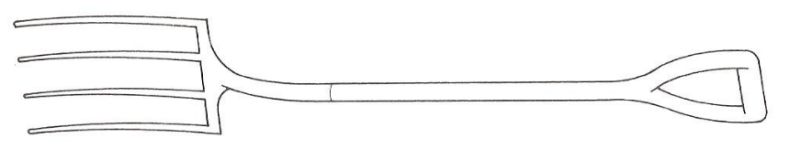

1. What is the importance of the above garden tool to a farmer?

………………………………………………………………………………………………..

1. Name one component of soil.

………………………………………………………………………………………………

1. How are annual crops different from perennial crops?

………………………………………………………………………………………………..

1. Name one insect pollinators.

………………………………………………………………………………………………..

1. Why is it not good to keep medicine near the children’s reach?

………………………………………………………………………………………………..

1. What name is given the larva stage of a mosquito?

………………………………………………………………………………………………..

1. How are prop roots useful to plants like maize?

………………………………………………………………………………………………..

1. Briefly explain the term immunization.

……………………………………………………………………………………………………………………………………………………………………………………………….

1. Give one example of poultry kept for security.

……………………………………………………………………………………………….

1. Why do we boil water for drinking?

……………………………………………………………………………………………….

1. Define digestion?

………………………………………………………………………………………………………………………………………………………………………………………………

1. What is the use of bile juice during the process of digestion?

………………………………………………………………………………………………..

1. In one sentence, explain what is meant by the term dislocation?

……………………………………………………………………………………………….

1. Which disease is spread by infected foxes and cats?

……………………………………………………………………………………………….

1. Mention any one example of mineral salts needed in the body?

………………………………………………………………………………………………..

1. What is a simple fracture?

………………………………………………………………………………………………………………………………………………………………………………………………

1. State one cause of scalds at home.

……………………………………………………………………………………………….

1. Give one result of the sun’s heat on a lake.

……………………………………………………………………………………………….

1. What happens when light meets an opaque object?

………………………………………………………………………………………………..

1. What is stocking the hive?

……………………………………………………………………………………………………………………………………………………………………………………………….

**SECTION B**

1. The diagram below shows a leg of a bird. Use it to answer the questions that follow.
2. Name the parts marked A and B

A ……………………………………………………………………………………….

B ……………………………………………………………………………………….

1. What is the function of part marked A

……………………………………………………………………………………………

1. Name any one example of domestic birds.

…………………………………………………………………………………………….

1. a.) Apart from honey, name any two products got from bees.

i. ……………………………………. ii. …………………………………………………….

b.) Name any two examples of traditional bee hives used in Uganda.

i. …………………………………… ii. ……………………………………………………..

1. a.) Define de-beaking?

………………………………………………………………………………………………………………………………………………………………………………………………

b.) Why do poultry keepers de-beak their birds.

………………………………………………………………………………………………

c.) Name any two examples of layers.

i. …………………………………………………………………………………………….

ii. ……………………………………………………………………………………………

1. Use the diagram below to answer the questions that follow.
2. Name the method of finding volume of the stone.

……………………………………………………………………………………………

1. Of what importance is part A during the finding of volume of a stone?

……………………………………………………………………………………………

1. Find the volume of a stone.
2. a.)Define non-communicable diseases.

………………………………………………………………………………………………………………………………………………………………………………………………

b.) Give any two examples of non-communicable diseases.

i. ……………………………………………………………………………………………...

ii. ……………………………………………………………………………………………..

c.) Give one way of controlling diseases apart from using drugs.

………………………………………………………………………………………………..

1. Study the diagram below and answer the questions that follow.

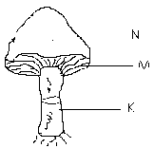

1. Name the part marked N and K

N ………………………………………………

K ………………………………………………

1. How is the part marked M important to the mushroom?

…………………………………………………………………………………………….

1. How does a mushroom reproduce?

…………………………………………………………………………………………….

1. a.)Define leaf venation?

……………………………………………………………………………………………………………………………………………………………………………………………….

b.) Name the two types of leaf venation.

i. ……………………………………. ii. ……………………………………………………

c.) Which type of leaf venation is common in monocotyledonous plants?

………………………………………………………………………………………………..

1. Match items in C with those in D correctly.

**C D**

Housefly - malaria

Blackfly - bubonic plaque

Rat fleas - river blindness

Anopheles mosquito - trachoma

1. Housefly ____________________________________
2. Black fly ____________________________________
3. Rat fleas ___________________________________
4. Anopheles mosquito __________________________
5. a.) Define the following terms
6. food

……………………………………………………………………………………………………………………………………………………………………………….

1. food hygiene

………………………………………………………………………………………………………………………………………………………………………………

b.) State any two ways how you can keep food free from germs

i. ……………………………………………………………………………………………

ii. ……………………………………………………………………………………………

1. The diagram below shows a cross section of an onion. Study it carefully and use it to answer questions given.

C D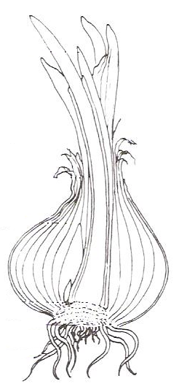 B

A

1. Name the parts marked B and C

B ………………………………………………….

C………………………………………………….

1. Of what importance is part A to an onion?

…………………………………………………………………………………………….

1. Give one importance of onions to man besides as food.

…………………………………………………………………………………………….

1. a.) Name the two types of digestion

i. …………………………………… ii. ……………………………………………………..

b.) How are the following important during digestion?

i. liver

………………………………………………………………………………………………..

ii. pancreas

………………………………………………………………………………………………..

1. a.) Define photosynthesis?

………………………………………………………………………………………………………………………………………………………………………………………………

b.) Apart from carbondioxide, name another raw materials needed by plants to make their own food.

………………………………………………………………………………………………

1. a.) Define the term mulches.

………………………………………………………………………………………………………………………………………………………………………………………………

b.) Outline any two examples of mulches

i. ………………………………………… ii. ………………………………………………..

c.) Why do farmers mulch their gardens?

………………………………………………………………………………………………..

1. Use the list below to answer the questions that follow.

* Beetroot - cassava
* Onion - white yam
* Sweet potato - garlic
* Irish potato - Banana

1. From the list above, name any two examples of bulbs.
2. …………………………………. ii. ………………………………………..
3. How do plants mentioned in (a) above.

………………………………………………………………………………………..

1. How do Irish potatoes and white yams propagated?

………………………………………………………………………………………..

1. a.) What is meant by the term seed germination?

………………………………………………………………………………………………………………………………………………………………………………………………

b.) Why does a seed need oxygen during germination?

……………………………………………………………………………………………….

c.) Give one reason why a seed may fail to germinate when all the necessary conditions are there.

………………………………………………………………………………………………..

d.) How can seeds be preserved to be planted in future?

………………………………………………………………………………………………..

**\*\*\* END\*\*\***

**ST. MARYS’ GIRLS PRIMARY SCHOOL**

**END OF JUNE PRIMARY FIVE SCIENCE**

**TERM TWO. 2018**

Name:……………………………………… Stream…………………

1. What is poultry?

…………………………………………………………………………………………………………………………………………………………………………………………………………………………………………

1. Identify the main reason farmers have for mulching their gardens.

…………………………………………………………………………………………………………………….

1. How does a chameleon protect itself from enemies?

…………………………………………………………………………………………………………………….

1. Infra-red light lamp brooder is not commonly used in rural places, give the reason why?

……………………………………………………………………………………………………………………..

1. Name the hardest part of a tooth.

……………………………………………………………………………………………………………………..

1. Give the meaning of the word thinning as used in crop growing.

……………………………………………………………………………………………………………………..

1. Outline one reason why all children in your class should maintain personal hygiene.

……………………………………………………………………………………………………………………

1. In the space below, draw a structure of a quill father.
2. Name any one type of poultry.

……………………………………………………………………………………………………………………..

1. Why do earth worms come out of the soil immediately after rainfall?

……………………………………………………………………………………………………………………..

1. Give any one adaptation of leaves to carry out photosynthesis.

………………………………………………………………………………………................................

1. Which type of weather requires one to use an umbrella?

……………………………………………………………………………………………………………………

1. Explain why a mushroom is not called a plant.

……………………………………………………………………………………………………………………..

1. Identify one effect of intestinal worms to the body.

……………………………………………………………………………………………………………………..

1. Name the largest internal body organ.

……………………………………………………………………………………………………………………..

1. What is transpiration?

………………………………………………………………………………………………………………………………………………………………………………………………………………………………………..

1. How does the farmer use the tool below?

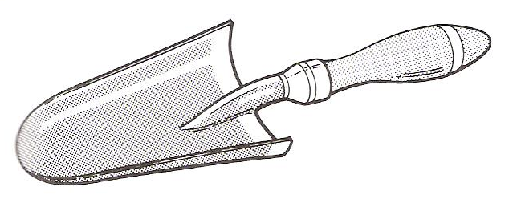

……………………………………………………………………………………………………………………..

1. Identify one condition for germination to take place.

……………………………………………………………………………………………………………………..

1. How many teeth does a normal adult person have?

……………………………………………………………………………………………………………………..

1. Of what benefit is the hairly body to a housefly.

……………………………………………………………………………………………………………………

1. Explain the meaning of sanitation.

………………………………………………………………………………………………………………………………………………………………………………………………………………………………………..

1. How can we prevent hook worm infection?

…………………………………………………………………………………………………………………….

1. What makes loam soil good enough for crop growing?

…………………………………………………………………………………………………………………….

1. Which body sense organ enables you to tell the taste of food?

……………………………………………………………………………………………………………………..

1. What is the deficiency disease caused by lack of proteins in the body?

……………………………………………………………………………………………………………………..

1. Differeciate between annual and perennial crops.

………………………………………………………………………………………………………………………………………………………………………………………………………………………………………………………………………………………………………………………………………………………………

1. Identify any one diarrhoeal disease you know.

……………………………………………………………………………………………………………………

1. Which is the best time for transplanting seedlings?

…………………………………………………………………………………………………………………….

1. Why is it not good to share cloths and towels with others?

…………………………………………………………………………………………………………………….

1. What is the incubation period of a hen?

……………………………………………………………………………………………………………………..

1. How important are stamata to plants?

……………………………………………………………………………………………………………………..

1. Give one way in which burning is similar to germination.

……………………………………………………………………………………………………………………..

1. To what extent is brushing of teeth important to a school going child?

……………………………………………………………………………………………………………………..

1. Name one viral poultry disease you know.

……………………………………………………………………………………………………………………..

1. Write the food value got from eating vegetables.

……………………………………………………………………………………………………………………..

1. How many stages of development does a cockroach under go?

……………………………………………………………………………………………………………………..

1. What name is given to the male part of a flower?

……………………………………………………………………………………………………………………..

1. Name the type of germination shown below.

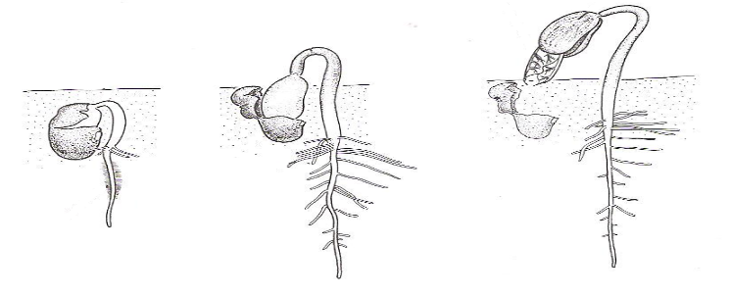

1. How can soil erosion be controlled in hilly areas?

……………………………………………………………………………………………………………………..

1. What is soil erosion?

………………………………………………………………………………………………………………………………………………………………………………………………………………………………………….

SECTION B

1. Use the diagram below, shows a structure commonly found in our homes. Use it to answer the questions that follow.

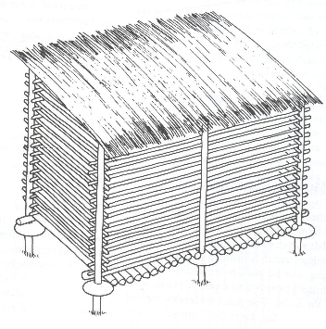 S

1. Name the structure drawn above;

…………………………………………………………………………………………………………..

1. What name is given to the part of the structure marked with letters?

……………………………………………………………………………………………………………

1. Give the importance of the above drawn structure in a home.

…………………………………………………………………………………………………………….

1. a.) What is tropism?

…………………………………………………………………………………………………………………………………………………………………………………………………………………………………………

b.) Name any two types of tropism you know.

i. ………………………………………………………………………………………………………………..

ii. ………………………………………………………………………………………………………………

c.) How does a plant obtain water from the soil?

………………………………………………………………………………………………………………….

1. a.) Give the meaning of pollination

…………………………………………………………………………………………………………………………………………………………………………………………………………………………………………

b.) Identify the two types of pollination.

i. ………………………………………………………………………………………………………………….

ii. …………………………………………………………………………………………………………………

c.) In the space provided draw a diagram showing one of the types of pollination identified in (b) above?

1. a.) How many teeth are in the milk set of teeth?

……………………………………………………………………………………………………………………

b.) Name any one disease that affects teeth.

…………………………………………………………………………………………………………………….

c.) List any two types of teeth you know.

i. ……………………………………………….. ii. …………………………………………………………….

1. a.) What is germination?

………………………………………………………………………………………………………………………………………………………………………………………………………………………………………….

b.) Identify any two types of germination.

i. …………………………………………………………………………………………………………………..

ii. ………………………………………………………………………………………………………………….

c.) How is micropyle useful to a bean seed during germination?

……………………………………………………………………………………………………………………..

1. a.) Use the diagram below to answer questions that follow.

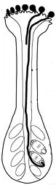 stigma

X

M

N

b.) What does part ‘M’ become after fertilization?

……………………………………………………………………………………………………………………

b.) Why is the stigma sticky?

……………………………………………………………………………………………………………………

c.) Name parts;

X: ……………………………………………………………………………………………………………….

N: ………………………………………………………………………………………………………………

1. Match the following deficiency diseases to their causes.

Deficiency disease Causes

Marasmus Vitamin C

Kwashiorkor Proteins

Scurvy Vitamin A

Night blindness Carbohydrates

1. Marasmus: ……………………………………………………………………………………..
2. Kwashiorkor:……………………………………………………………………………………
3. Scurvy: …………………………………………………………………………………………….
4. Night blindness: ………………………………………………………………………………..
5. a.) What is personal hygiene?

…………………………………………………………………………………………………………………………………………………………………………………………………………………………………………

b.) Why should clothes be ironed before putting on?

…………………………………………………………………………………………………………………….

c.) Identify any other two elements of primary health care apart from personal hygiene.

i. ……………………………………………………………………………………………………………..

ii. ……………………………………………………………………………………………………………..

1. a.) Give one reason why photosynthesis does not take place at night.

…………………………………………………………………………………………………………………

b.) Name one condition needed for photosynthesis to take place.

……………………………………………………………………………………………………………….

c.) What are the two raw materials needed for photosynthesis to occur?

i. ……………………………………………………………………………………………………………….

ii. ………………………………………………………………………………………………………………

1. a.) Give the difference between poultry and poultry keeping.

………………………………………………………………………………………………………………………………………………………………………………………………………………………………………….

b.) Name any two systems of keeping poultry.

i. …………………………………………………………………………………………………………………..

ii. ………………………………………………………………………………………………………………….

c.) Why should a farmer keep the deep litter house clean and dry all the time?

……………………………………………………………………………………………………………………..

1. Use the diagram below and answer the questions that follow.

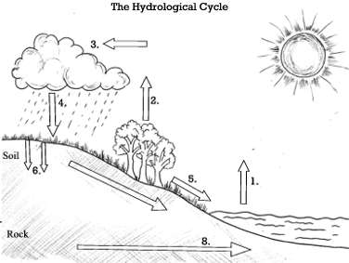

1. Name the process shown above.

……………………………………………………………………………………………………………………

1. Identify any two physical changes involved in the process.
2. …………………………………………………………………………………………………………..
3. …………………………………………………………………………………………………………..
4. How important is the sun in the process above?

…………………………………………………………………………………………………………………….

1. a.) What is soil profile?

………………………………………………………………………………………………………………………………………………………………………………………………………………………………………..

b.) Which part of the soil profile supports plant growth?

……………………………………………………………………………………………………………………

c.) Name any two types of soil.

i. …………………………………………………………………………………………………………………..

ii. ………………………………………………………………………………………………………………….

1. a.) Name any two examples of leguminous crops.

i. ………………………………………………. ii. …………………………………………………………….

b.) How important are leguminous crops to the soil?

……………………………………………………………………………………………………………………..

c.) What food value do we get from eating leguminous crops like ground nuts?

……………………………………………………………………………………………………………………..

1. a.) How important is the brain to people?

…………………………………………………………………………………………………………………….

b.) Name the body organ that filters blood.

…………………………………………………………………………………………………………………….

c.) Name any two internal body parts or organs.

i. ………………………………………………………………………………………………………………..

ii. ………………………………………………………………………………………………………………..

1. a.) Give the meaning of crop rotation.

…………………………………………………………………………………………………………………………………………………………………………………………………………………………………………

b.) What are crop pests?

…………………………………………………………………………………………………………………………………………………………………………………………………………………………………………

c.) How does crop rotation help to control pests?

……………………………………………………………………………………………………………………

d.) Why do farmers mulch their gardens?

……………………………………………………………………………………………………………………